**New predicted crystal structures**

Structural data of the new phases predicted with USPEX and AIRSS codes are summarized in Table 1 and shown in Fig. 1. The structures of Ni14P, Ni12P, Ni10P, Ni8P, Ni7P, and Ni5P are characterized by fcc-Ni lattice in which Ni atoms substituted by P in a certain amount, i.e. this structures are isomorphic to the fcc-Ni. The coordination polyhedrons in these structures are cuboctahedrons. The P atoms in these structures tend to be located as far as possible from each other. The minimum P-P distance in these structures varies from 5.08 Å (in Ni14P) to 3.69 Å (in Ni5P).

The structure of Ni3P-*Cmca* is characterized by distorted fcc-Ni lattice. Due to the higher P content in the structure, P atoms are located closer to each other, which causes lattice distortion. The coordination polyhedron is distorted cuboctahedron (Fig. 3). The minimum P-P distance is 3.17 A. The predicted Ni2P-*Pnma* is isostructural to Fe2P-allabogdanite.

Figure 3. Coordination polyhedrons in fcc-Ni (a), Ni5P-*P*63/*mcm* (b), and Ni3P-*Cmca* (c).

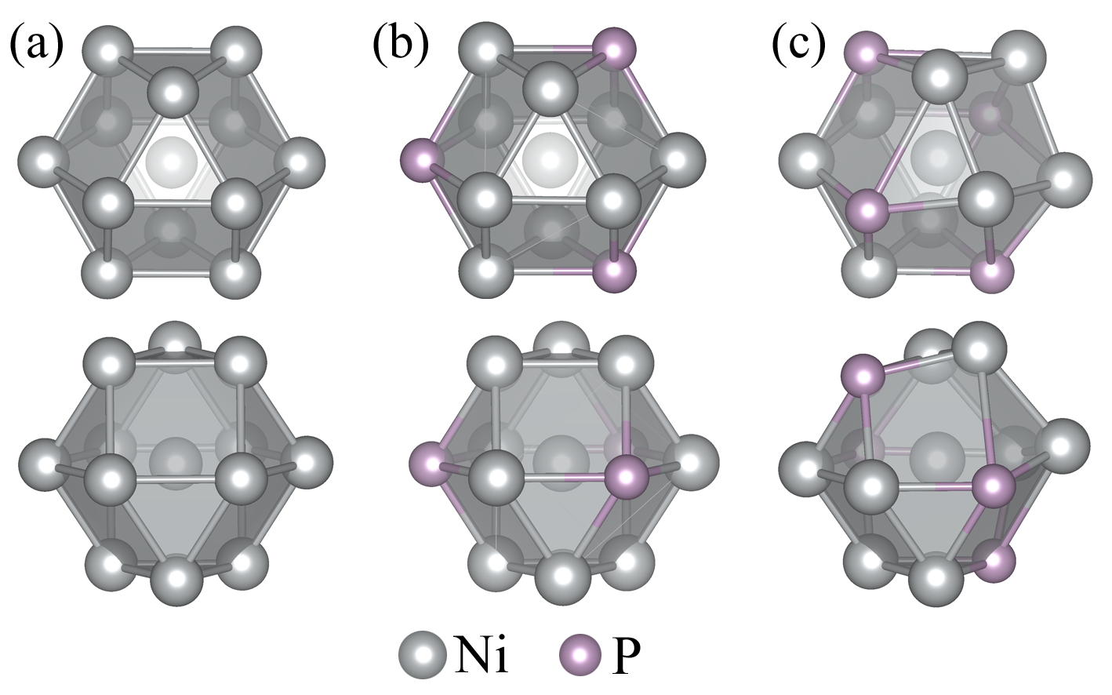

(Далее, чтобы было как в статье Талгата Муратовича, вставил часть про магнитный момент)

Spin-polarized calculations show the presence of a magnetic moment in structures with relatively high nickel content from Ni14P to Ni8P, as shown in Fig. 6. In all other cases, the magnetic order is absent. The magnetic moment per nickel atom decreases with an increase in the specific phosphorus content in the system. With increasing pressure, the magnetic moment and magnetic ordering completely disappear at a pressure of 315, 360, 350, and 115 GPa for the Ni14P, Ni12P, Ni10P, and Ni8P, respectively.